Cleaning Task Questionnaire

**What is your participant ID? ____________**

**How satisfied are you with the notebook you made?**

(Fill one of the 7 bubbles)

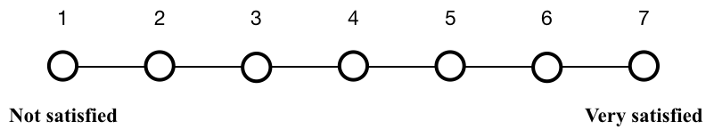

**How easy was it to make the notebook you wanted?**

(Fill one of the 7 bubbles)



**How enjoyable was it for you to make the new notebook?**

(Fill one of the 7 bubbles)

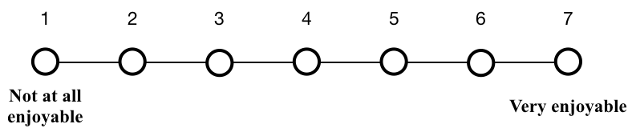

**How useful do you think this notebook you made would be to another analyst that was trying to verify the results of the analysis?**

(Fill one of 7 bubbles)

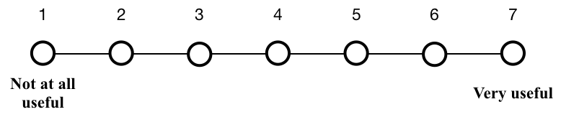

# Questions for Condition D

**What did you do to clean the notebook? (1-2 sentences)**

**What else would you do to clean the notebook if you had more time? (1-2 sentences)**

Thank you for your feedback!

# Questions for Condition E

**What else would you do to clean the notebook if you had more time? (1-2 sentences)**

**How useful were each of the following gathering features when you were cleaning the notebook?** (Select one for each row)

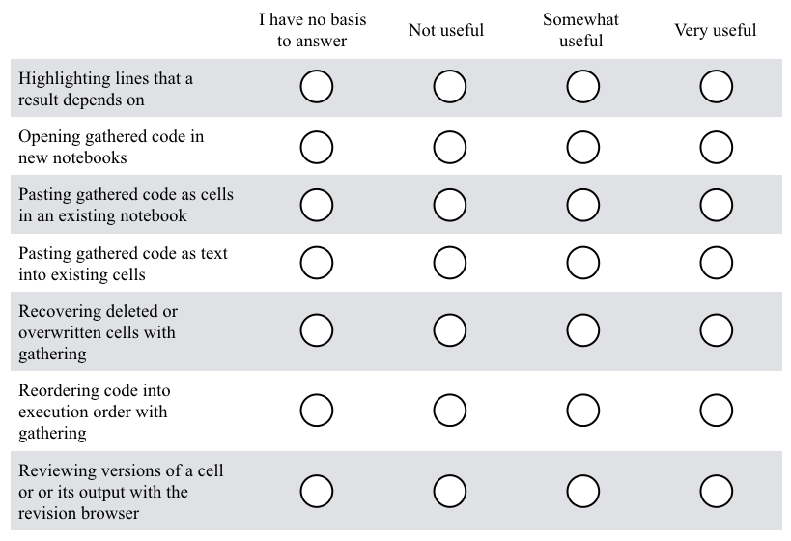

**Please explain (1-2 sentences)**

**What aspects of notebook cleaning do you still wish were easier when cleaning up and re-organizing a notebook with the gathering tool?** (1-2 sentences)

Thank you for your feedback!